Daily Yogasana order

1)Hands on Legs Bending

2)Hand stretch Bending

3)Hands Side swinging

4)Trikonasana

5)Uttita Konasana

Ganesha Namaskara

Standing

1)Tadasana

2)Yoga nadige

3)Utkatasana

4)Vrikshasana

5)Ardhakatichakrasana

6)Veerabhadrasana(3 Stages)

7)Back bend

8)Pada Angustasana

9)Back leg stech

10)Natarajasana

11)Garudasana

12)Malasana

Sitting

1)Stretch legs-Fold-Unfold

2)Legs Side swinging

3)Legs Rotating

4)Legs in V Shape-Hand Stretch and lift

5)Ragi beesodu

6)Baddakonasana1

7)Baddakonasana2

8)Gomukhasana

9)Hands Crossing

10)Vakrasana

11)Parigaasana

12)Janu Shirshsana

13)Soundaryasana

14)Sampoorna Soundaryasana

15)Anjaneyasana

16)Ekalavyasana

17)Matsyendrasana

18)Balalasana

19)Shwanasana

Sleeping

1)Cycling

2)Left Pavanmuktasana

3)Right Pavanmuktasana

4)Sethubhandasana

5)Ardha Chakrasana

6)Naavasana

7)Anantasana

8)Ananda Baalasana

9)Folded Janu side swing

Lying on Stomach

1)Urdhwa Namaskaraasana

2)Shalabasana

3)Dhanurasana

4)Makarasana

Surya Namaskar

Vishnu Namaskar

1)Purvottanasana(Inclined Plane)

2)Supta Natarajasana(Lying down body twist)

3)Supta Baddakonasana

4)Supta Padaangustasana(Reclining Hand to Toe)

5)Salamba Sarvangasana(Supported Shoulder Stand)

6)Upavista Konasana(Wide angle seated forward bend)

7)Padmasana

8)Skandasana

9)Uttita Parshvakonasana(Extended Side-angled pose)

10)Pyramid pose

11)Eka pada Utkatasana(Figure 4 pose)

12)Parivritta Utkatasana(Bent Utkatasana)

13)Parsva Balasana(Bird Dog pose)

14)Mandukasana

15)Dolphin

16)Chaturanaga Dandasana(Four limbed Staff pose)

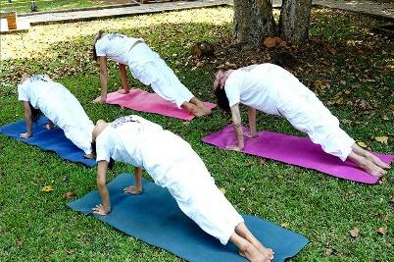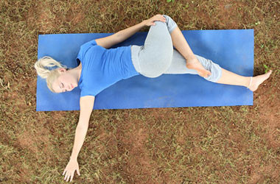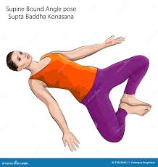  

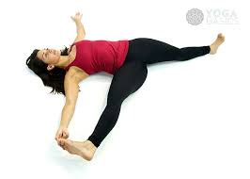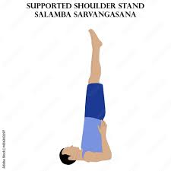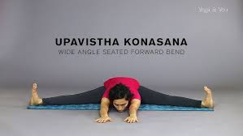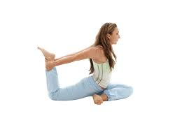 

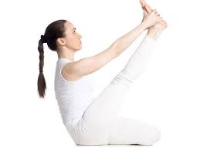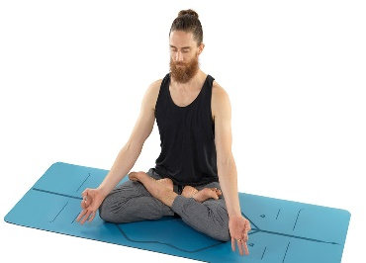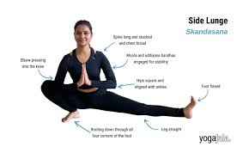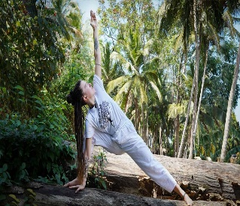

Padmasana

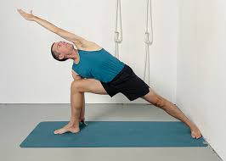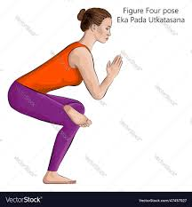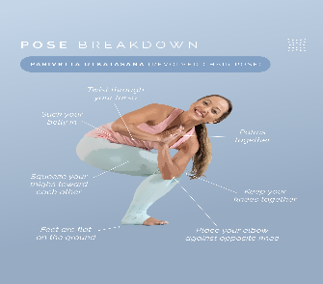

 Pyramid

